Globalization is a process of interaction and integration among the people, companies, and governments of different nations, a process driven by international trade and investment and aided by technology. This process has effects on the environment, culture, political systems, economic development and prosperity, and on human physical well-being in societies around the world.
Globalization and technological innovation are interdependent processes. It has a fundamental influence on the creation and diffusion of technology which, in turn, affects the interdependence of multinational corporations and where they locate their activities.
Technology and globalization go hand-in-hand. Globalization unleashes technology, which in turn drives firms to plan production and sales on a global basis. Technology changes the work we do and in nearly all cases, the jobs created by it demand more education and training. It also changes the way business operates by transforming relationships between suppliers, producers, retailers and customers.
Technology can be defined as science applied to practical purposes. A first and major advantage is that medical science is very progressive and vastly available. Without the needed technology a lot of people would struggle with their health. In addition it saves many innocent lives. The point is to spread it and reach with medicine help to the poor nations of the Third World. Secondly, the advanced technology improves industry by making it more effective and, what is vital today, safer for environment.
Business organizations have also made possible the exchange of cultures and ideas across the continents. The world had become "flat" in terms of how information is shared and received; how business and trade is done; and how people from different countries interact with each other. Technology has broken down walls and divisions that have kept many countries and people apart.
It is quite clear that many information technology jobs are increasingly being conducted offshore. One of the largest beneficiaries to U.S. outsourcing of information technology jobs has been India. With an English speaking language, 520,000 IT engineers, and starting salaries around $5,000, India has become extremely attractive for American businesses. Because of large workforces and cheaper labor, China and the Philippines have also increasingly been targets for information technology outsourcing.

- Medical Science
- Divisions
- Flat World
- Education and Training
- Creation and Diffusion
- Ex.: India
- China and Philippines
- Practical Purposes
- International Trade
- Investment
- Technology
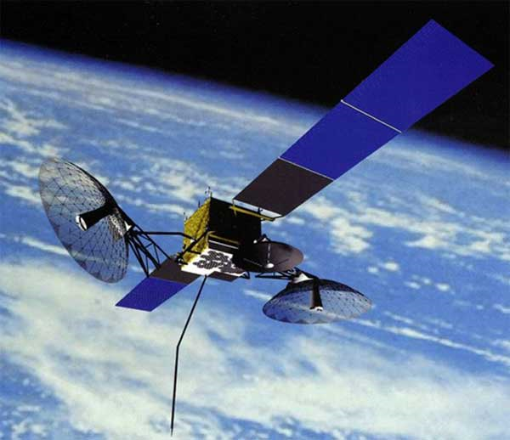
and
Technology

Globalizaation
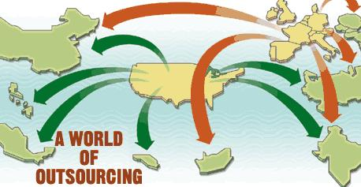
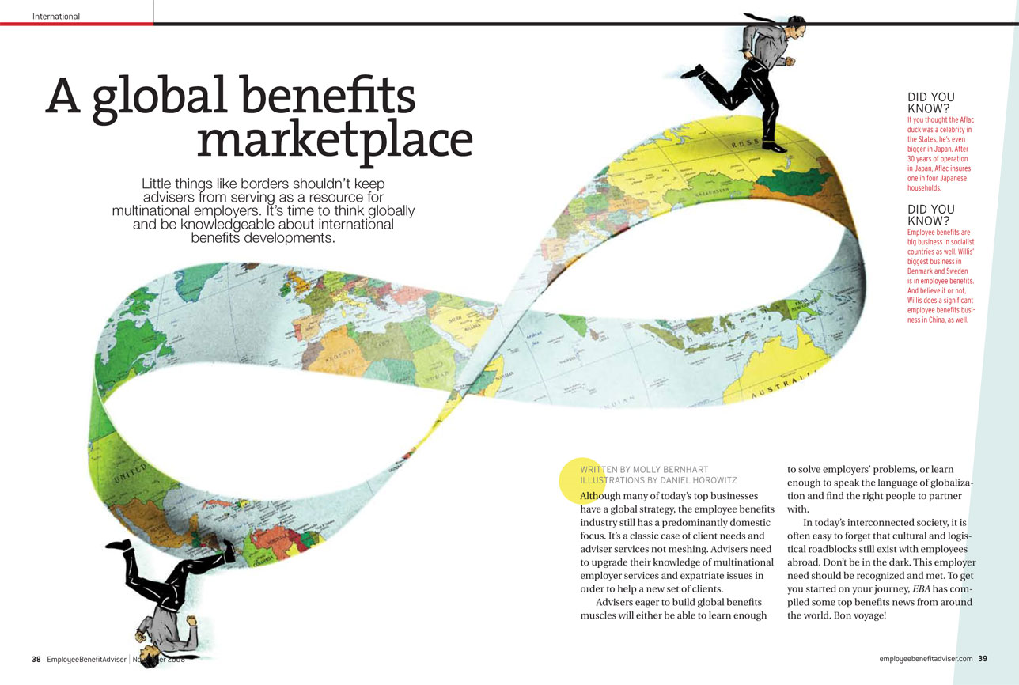
The definition of globalization has changed and evolved over the years. Today, it is used to describe a continuous process wherein societies, cultures, and economies are integrated by means of global communication and exchange network.
The term is also often used to represent changes in political, technological, and sociocultural environments. Since globalization has had such a widespread impact, it is but natural that people have perceived it in many different ways
World Bank, the International Monetary Fund (IMF), and the World Trade Organization (WTO) are organizations at the center of a great debate over globalization.
Economic Theory
Economic theory indicates that the outsourcing of IT jobs will ultimately prove beneficial to American society. Economists claim that the outsourcing of routine jobs requiring little supervision will ultimately create new higher paying jobs. Strong evidence supporting this theory already exists.
The manufacturing industry provides an ideal example by demonstrating that outsourcing does create jobs. Technology jobs are being outsourced today and Education needed to play a major role for this occurrence to unfold. The re-training of laborers to help supply them with the skills necessary to perform more complex tasks was required.
Technology helps to make globalization possible. Because computers can be interlinked across companies, countries and continents, information is no longer weighed down by geography or time.
Dimensions of Globalization rcing
Within the past decade, the idea of outsourcing has integrated itself into virtually every industry imaginable. The information technology industry has not only experienced heavy doses of outsourcing, but it has led the charge for other white-collar industries to follow. Every week, headlines describing the threat of outsourcing cover magazines and newspapers. Many United States citizens are extremely concerned with the outsourcing of Information Technology jobs because they account for several areas within a corporation. Below is a list of the top IT jobs currently being outsourced.
Primary Information Technology Jobs Being Outsourced

- Call Centers | - System Integration | - IT Consulting
- Software Development | - Financial Services | - Billing Services
- Application Maintenance | - Backoffice Support | - Networking Services
- Software Testing | - Customer Support | - Technical Support
- Product Support | - Wireless Services | - Commerce
- Data Processing | - Design Services

Why Outsource?
Perhaps the most frequently observed explanation for why companies decide to outsource jobs is the desire to increase profits. Through the reduction of labor costs, companies are more capable of competing in the global marketplace by selling their products and services at a lower price. According to a survey conducted by J. Collins and R. Millen, the top causes for outsourcing informational services are as follows:
- Focus in-house resources on core functions
- Personnel cost savings
- Improved quality of information systems services
- Increased flexibility
- Increased access to new technology
- Provide alternatives to in-house costs
- Stabilize information systems costs
- Technology cost savings
- Re-engineer process
- Reduce technological obsolescence riskutsourcing


The Positive Perspective

Globalization means increasing the interdependence, connectivity and integration on a global level with respect to the social, cultural, political, technological, economic and ecological levels.
Globalization has also created a tremendous benefit and will likely generate positive long term effects. A topic seldom discussed in contemporary society is the concept of "insourcing," the investment of foreign companies in the United States. Insourcing can be described as foreign direct investment, an area of enormous importance.
According to the Washington Council on International Trade statistics, insourcing currently accounts for over 6.5 million jobs nationwide. it can be stated that during the period when outsourcing has become a tremendous issue, insourcing has actually been more relevant.

Advantages of Globalization

- Goods and people are transported with more easiness and speed
- the possibility of war between the developed countries decreases
- Free trade between countries increases
- Global mass media connects all the people in the world
- Global village dream become true as the cultural barriers reduce
- There is a propagation of democratic ideals
- The interdependence of the nation-states increases
- The flexibility of corporations to operate across borders increases
- Communication between individuals and corporations increases
- Environmental protection in developed countries increases
Effects of globalization

- A broad access to a range of goods for consumers and companies
- worldwide production markets emerge
- People from different nations leads to social benefits
- More transborder data flow using communication satellites, the
Internet, wireless telephones etc.
- Multiculturalism spreads by individual access to cultural diversity
- International travel and tourism increases
- Local consumer products are exported to other countries
- An increase in the desire to use foreign ideas and products to adopt new practices and technologies
- Ocean shipping and the transportation costs are reduced

r

Advantages of globalization in the developing world
Globalization increases the economic prosperity and opportunity in the developing world. There is a more efficient use of resources, and all the countries involved in the free trade are at a profit. As a result, there are lower prices, more employment and a better standard of life in these developing nations. Globalization is a positive-sum chance in which the skills and technologies enable to increase the living standards throughout the world. Liberals look at globalization as an efficient tool to eliminate penury and allow the poor people a firm foothold in the global economy. In two decades from 1981 to 2001, the number of people surviving on $1 or less per day decreased from 1.5 billion to 1.1 billion. Simultaneously, the world population also increased. Thus, the percentage of such people decreased from 40% to 20% in such developing countries.

The True Benefits of Globalization
Globalization happens to be great for the country and the overall market economy because it promotes prosperity to participating countries. All that we need to do is educate people on multiculturalism and diversity within the work place, as well as the sensitivity of culture within participating countries.
Here are several benefits of globalization that you should know: trade terms, comparative advantages, changes in consumption and production, and how much cheaper it is to purchase than to produce.

